Computerized Rideshare Program

**User Manual**

Group B

**About**

This document provides an overview of how to work with and use the Computerized Rideshare Program (CRP). The CRP is limited in its use to the employees of the Southern North Dakota University (SNDU). The aim of the program is to cut down on costs for commuting employees and to alleviate overcrowding in the SNDU parking lots. In the following sections this document will provide information on how the CRP system works and how to go about using it. Images will be provided when necessary to better guide the user.

The CRP was created by:

|  |  |
| --- | --- |
|  | Subramanian Arumugam |
|  | Mohanakrishnakumar Karunakaran |
|  | Rajeev Reddy Vishaka |
|  | Saulius Milevicius |
|  | Steven Rago |

**Table of Contents**

1. **System 0**
   1. Registering **0**
   2. Logging in **0**
   3. Points **0**
   4. Member Types **0**
   5. Notifications **0**
   6. Opting out **0**
2. **Carpool 0**
   1. Allotment **0**
   2. Schedule **0**
   3. Passenger Capabilities **0**
   4. Driver capabilities **0**
   5. Editing your details **0**
   6. Opting out **0**
   7. Selecting a new carpool **0**
3. **FAQ 0**

**A.** **System**

The CRP system runs as a web application on SNDU’s servers meaning that you can access it anywhere you have access to an internet connection. The system enables employees to quickly learn who is in their carpool, what duties they have that day and enables a fair share point system for the members of the system.

Before using the system the SNDU employee must first either register, if this is the first time using the system, or log in.

**1. Registering**

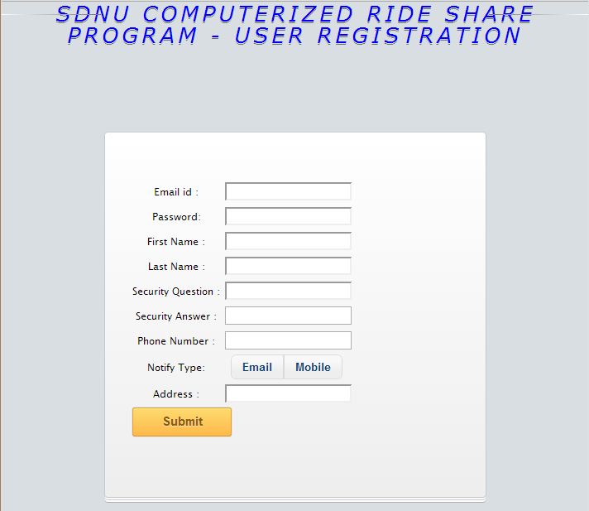

Please provide a valid email id, which will be used to send notifications by the CRP. All the fields in the form are mandatory. However, you can make a choice of either using an Email or mobile for the notifications. The default way of notification is set to email.

Once you have entered all the details, click on Submit button. Once you click on submit button, system automatically allocates the user to the particular carpool and details are displayed as follows. Each car pool group member can be identified by his name. “Is Driver” field is displayed as shown in the screen shot. If it’s specified to be 1 beside the name of the user, he is the driver for that day. If it’s specified to be 0 meant to be the passenger.

**2. Logging in**

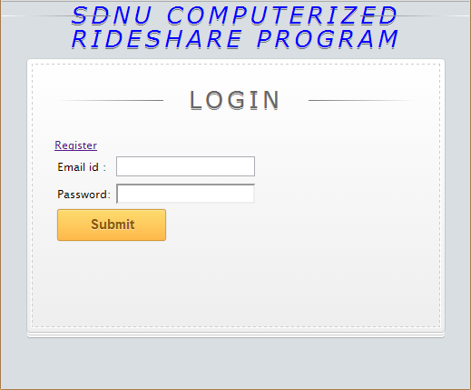

Registered users need to enter their username and password to use the application. Each of the fields is mandatory. New users have to click on register link above the Email id field and provide the information. The Register screen is shown below.

**3. Points**

A new member of the system starts out with 10 points. Points are gained for driving a carpool to and from work and point deductions are given for various actions. Consult the following table for when points are deducted from a members account.

|  |  |
| --- | --- |
| **Reason** | **Amount** |
|  |  |
|  |  |
|  |  |
|  |  |
|  |  |

**4. Member Types**

A member can be either a passenger or a driver.

**Driver:**

**Passenger:**

**5. Notifications**

Notifications are sent out to the email that was provided during registration. Reasons for sending out notification are, but are not limited to:

* Member cancels pickup
* Member cancels driving

Optionally, you may select to be sent notifications via the mobile phone number you registered with.

**6. Opting out**

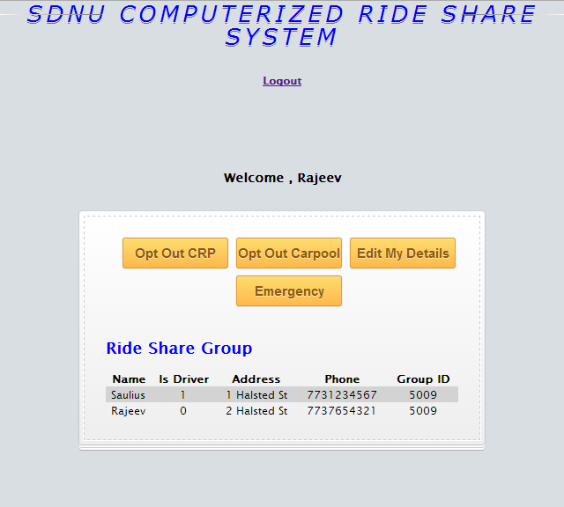

If you would like to completely move out of using CRP. All your personal details will be removed from the SNDU Databases. Afterwards you will be taken back to the login screen.

**B. Carpool**

A carpool is defined as a group of four members that share a single member’s car to drive to and from work, thereby reducing the amount spent on gas as well as alleviating overcrowding at SNDU.

**1. Allotment**

Members are assigned into carpools as they join the system. A carpool is composed of 4 members. When a member joins the system they are either placed into any existing carpool with less than four members or the system allocates a new carpool and places the new member into that carpool.

The member that is first assigned into a new carpool becomes that carpool’s first driver, whereas any future employees will be passengers.

A member can, at any time assuming they have enough points, opt out of their carpool and join any existing carpools that have less than four members.

**2. Carpool Schedule**

The carpool system runs on a weekly schedule. An employee stays a driver for a week, after which the member that comes after the employee in the carpool group list becomes the driver the following week.

The system sends out a notification to each member every morning detailing who is participating in the carpool that day. (**?not sure if this is implemented, need to check?**)

**3. Passenger Capabilities**



**Log out:** Log out link is present on the top, clicking on that will log you out of the application.

**Opt Out Carpool:** CRP automatically assigns a user to the carpool group. If the user would like to move out of a particular group and would like to join the next group he/she can click on this button. Once clicked all the details pertaining to the user in a particular group are deleted and recreated when joined a new group.

**Canceling Pickup:**

**Editing Details:**

**Issuing an Emergency:**

**4. Driver capabilities**

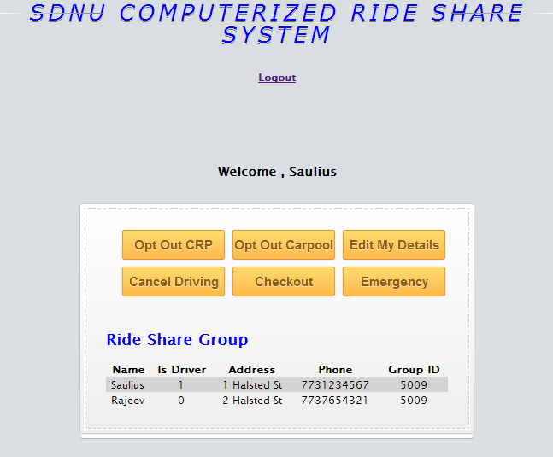

**Log out:** Log out link is present on the top, clicking on that will log you out of the application.

**Opt Out Carpool:** CRP automatically assigns a user to the carpool group. If the user would like to move out of a particular group and would like to join the next group he/she can click on this button. Once clicked all the details pertaining to the user in a particular group are deleted and recreated when joined a new group.

**Editing Details:**

**Canceling Driving:**

**Issuing an Emergency:**

**Check in/out Carpool:**

**5. Editing your details**

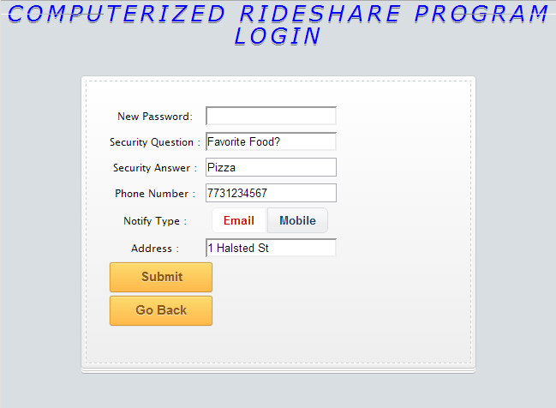

If user would like to update their information like change of address, Phone Number or password. This button would display below screen. Once you are done with entering all the details please click on Submit and changed details would be displayed again.

**6. Opting out**

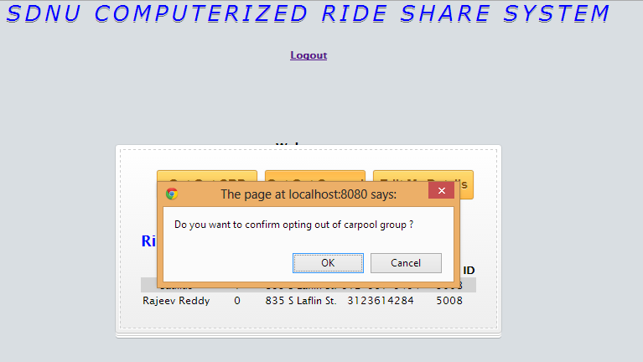

**7. Selecting a new carpool**

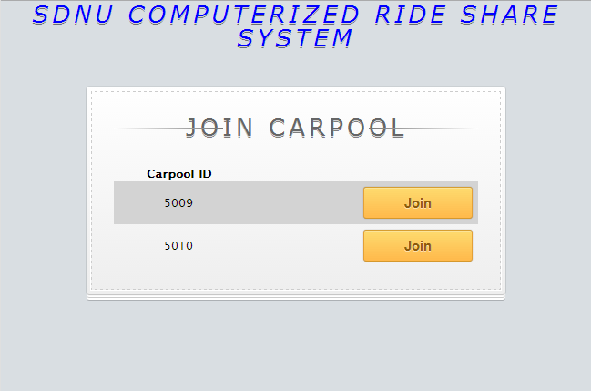

Once clicked on the button “join” beside the carpool id, the same screen of members in carpool will be shown.

**C. FAQ**